Distributed Transaction

Definition
# Source: AI Source: Provided by: [Data Path: Persons Table -> ID Column: 1, Name_En Column: Motasem Essam] -> From: [Chatgpt (GPT‑5 Mini)] on [12/10/2025]
A Distributed Transaction is a transaction that involves multiple systems, databases, or servers working together as one unit of work.
- The operations are executed across different locations.
- All parts must succeed together, or all changes are rolled back.
Key idea:
Even though data is spread across multiple systems, the transaction behaves like a single transaction.

How Distributed Transactions Work
# Source: AI Source: Provided by: [Data Path: Persons Table -> ID Column: 1, Name_En Column: Motasem Essam] -> From: [Chatgpt (GPT‑5 Mini)] on [12/10/2025]
- A coordinator manages the transaction across multiple systems
- Each system (participant) performs its part of the work
- Systems communicate to confirm success or failure
- If all systems succeed → Commit
- If any system fails → Rollback across all systems

Two-Phase Commit (2PC)
# Source: AI Source: Provided by: [Data Path: Persons Table -> ID Column: 1, Name_En Column: Motasem Essam] -> From: [Chatgpt (GPT‑5 Mini)] on [12/10/2025]
Distributed transactions often use the Two-Phase Commit protocol:
1️⃣ Prepare Phase
- The coordinator asks all systems: “Can you commit?”
- Each system prepares and responds (Yes/No)
2️⃣ Commit Phase
- If all systems respond “Yes” → commit the transaction
- If any system responds “No” → rollback the transaction

Example
# Source: AI Source: Provided by: [Data Path: Persons Table -> ID Column: 1, Name_En Column: Motasem Essam] -> From: [Chatgpt (GPT‑5 Mini)] on [12/10/2025]
Online Shopping Example:
- You order a product from a website
Steps:
- Deduct money from your bank account
- Update order status in the store database
- Reduce product stock in inventory system
- All systems must succeed
- If payment succeeds but inventory update fails → the transaction is rolled back

Key Characteristics
# Source: AI Source: Provided by: [Data Path: Persons Table -> ID Column: 1, Name_En Column: Motasem Essam] -> From: [Chatgpt (GPT‑5 Mini)] on [12/10/2025]
- Involves multiple systems or databases
- Managed by a transaction coordinator
- Uses protocols like Two-Phase Commit
- Ensures consistency across distributed systems
- Complex compared to single transactions

Advantages
# Source: AI Source: Provided by: [Data Path: Persons Table -> ID Column: 1, Name_En Column: Motasem Essam] -> From: [Chatgpt (GPT‑5 Mini)] on [12/10/2025]
- Enables operations across multiple systems
- Maintains data consistency in distributed environments
- Supports large-scale applications
- Ensures reliability in complex systems
- Keeps all systems synchronized

Disadvantages
# Source: AI Source: Provided by: [Data Path: Persons Table -> ID Column: 1, Name_En Column: Motasem Essam] -> From: [Chatgpt (GPT‑5 Mini)] on [12/10/2025]
- Complex to implement and manage
- Slower due to communication between systems
- Higher risk of failures due to network issues
- Requires more resources and coordination
- Can cause delays in system performance

Summary
# Source: AI Source: Provided by: [Data Path: Persons Table -> ID Column: 1, Name_En Column: Motasem Essam] -> From: [Chatgpt (GPT‑5 Mini)] on [12/10/2025]
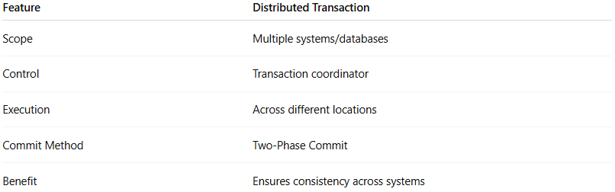
Feature | Distributed Transaction
Scope | Multiple systems/databases
Control | Transaction coordinator
Execution | Across different locations
Commit Method | Two-Phase Commit
Benefit | Ensures consistency across systems

